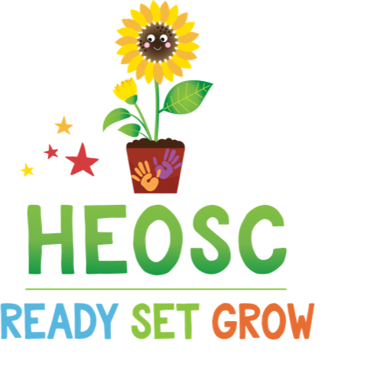
Ready Set Grow Hillcrest Community Preschool
4421 Greentree Terrace
Victoria BC V8N 3S9
Tel: 250-472-1530 Toll Free: 1-877-881-4066
Email: heoscmanager@gmail.com

2024/25 Registration Form

Child’s Name:

Child’s Birthdate (Month/Day/Year):

*All children must be toilet trained to attend Ready Set Grow Preschool*

✓ | Program Requested | Days Requested
 | Two days per week | Tue + Thur
 | Three days per week | Mon + Wed + Fri
 | Five days per week | Mon + Tue + Wed + Thur + Fri

Provincial Child Care Regulations require that we must have all the information requested in the registration form on file for each child.

Please ensure all items on the check-list below have been completed and attached prior to returning to HEOSC. Incomplete packages will not be processed and will be returned to you.
✓ | Registration Checklist (check only if completed)
 | Registration form fully completed & signed
 | $50 non-refundable registration processing fee (cheques made out to HEOSC)
 | Immunization dates provided – form filled in or photocopy accepted
 | Legal copy of custody restrictions (if applicable)
 | Government subsidy authorization (if applicable)
 | Recent photo of your child
 | Automatic payment form

A program offered by Hillcrest Elementary Out of School Care Society – a non-profit organization offering quality child care since 1993

Ready Set Grow Preschool 2024/25 Registration Form
Family  Information | Gender:  M  F  Birth Date M/D/Y:  Postal Code:  Gender:  Child:  Address:  Home #:  Parents/Guardians:  Sibling’s Names + Ages:  Cell #:  Postal Code:  Work #:  Email:  Parent’s Name:  Address:  Employer:  Home #:  Parent’s Name:  Address:  Employer:  Home #:  Cell #:  Postal Code:  Work #:  Email:
Custody  Restrictions | ❑ Yes  No  If yes, please attach court order or custody and access terms of separation agreement and state any general conditions here:
Medical  Information | Care Card #:  Family Doctor: Phone #:  1) Does your child take any medications?  Yes  No  - If “Yes”, please list below, under “Medications”  2) Does your child have an epi-pen?  Yes  No  - If “Yes” to either of the above please see the Manager or Preschool Leader for appropriate form.  3) Does your child require a Supported Child Development (SCD) Worker?  Yes  No  - If “Yes” please see the Manager or Preschool Supervisor.  Please describe any health conditions, disabilities, or concerns your child may have (learning, developmental, physical, etc):  Medications:  Allergies to medications:  Other allergies or dietary restrictions:  Please discuss with the Manager for relevant policies.
Emergency  Contacts | Name:  Relationship:  Cell#:  Work#:  Name:  Relationship:  Cell#:  Work#:
Person(s)  Authorized to  Pick Up Child  Other Than  Parents |  Check if same as above  Name:  Relationship:  Cell#:  Work#:  Name:  Relationship:  Cell#:  Work#:  Name:  Relationship:  Cell#:  Work#:
Record of  Immunization | Please complete the chart by entering the DATES (mm/dd/yy) your child received the immunization indicated. This information is required by legislation to be filled out – Photocopy of record is acceptable.  1st Visit (2 months) 2nd Visit (2 months after 1st) 3rd Visit (2 months after 2nd) 4th Visit (12 months) 5th Visit (12 months after 3rd) 5 – 6 yrs  Diphtheria  Pertussis  Tetanus  Poliomyelitis  Haemophilus  Influenza  Type B  Pneumoncoccal  Conjugate  Hepatitis B  Measles, Mumps & Rubella  Meningococcal C  Varicella  (chicken pox)

Permissions  Information collected by the program is used for the care and control of the children. Much of the information is required by legislation. Parents have the right to opt out of providing information but please be aware that this may affect our ability to provide service. If you have any questions about the information required, please contact the Program Manager. | MEDICAL PERMISSION  As Parent/Guardian, I authorize the staff of Hillcrest Elementary Out of School Care Society (aka HEOSC), to release my child into the care of the emergency contact person due to illness or minor injury, or in an emergency, call an ambulance for appropriate care. I understand that HEOSC will contact me as soon as possible.  Signature ________________________________________ Date ______________  PERMISSION TO COMMUNICATE  I give permission for HEOSC to disclose information with Hillcrest Elementary regarding my child whenever necessary. It may be important from time to time for the staff of HEOSC to both give and receive information regarding my child.  Signature ________________________________________ Date ______________  PERMISSION FOR JOURNEYS  HEOSC occasionally leaves HEOSC with the children in the program for journeys to local parks, beaches, playgrounds, and attractions and will walk. As parent/guardian, I give written consent for my child to participate in the outings away from HEOSC. I fully understand that every reasonable precaution and safety measure will be adhered to by the staff.  Signature ________________________________________ Date ______________  PERMISSION FOR PICTURES  As parent/guardian, I give permission for staff at HEOSC to take pictures of my child for the purposes of a birthday display and other bulletin board displays within the Program facility. Pictures may be kept in photo albums for historical purposes. Photos may also be used in the monthly newsletter, distributed to families of children in our program.  Signature ________________________________________ Date ______________  PERMISSION FOR SUNSCREEN  I give permission for my child to use HEOSC’s sunscreen.   Is permitted to use HEOSC’s sunscreen (Coppertone Kids, non-PABA formula spray)   I am supplying a labeled bottle of sunscreen for my child (include child’s name and room #)  Signature: ________________________________________ Date: _____________

PROGRAM CONTRACT
I understand and agree to:
- Give one month's written notice due by the first of the month if I plan to withdraw my child, change days, reduce service, or change the days of the week service is desired
- If I do not give sufficient notice, I am responsible for payment of fees in lieu of notice.
- Upon registration I will submit a $50/family non-refundable application fee. This fee also confers membership status within HEOSC.
- Be invoiced at the beginning of the school year or commencement of service.
- All fees for each month are due at the beginning of the school year, in post-dated cheques due the 1st of each month.
- It is H.E.O.S.C. policy to issue receipts once per calendar year. If receipts are requested during the year and are subsequently lost, I understand there is a $10/receipt replacement charge.
- A late fee of $5/day may be charged on all fees outstanding.
- If I am late picking up my child, a late fee of $1.00 per minute per child will be levied and payable to the staff upon arrival.
- I will contact the Program if my child will not be attending on a particular day, will be away for an extended period of time, or my child will be picked up by someone not on the authorized pick-up list.
- I will have my child arrange playdates ahead of time. Notice will be given in advance and in writing (email/note to staff at the beginning of the day).
- I will notify the Manager in writing of address changes, work or home phone number changes, or special instructions regarding my child.
- I agree and accept all policies in the parent handbook.
Signature ___________________________________________ Date ______________
Signature ___________________________________________ Date ______________
For Internal Use Only | Photo: ___ PAD / Chq Imm: ___ Sign: ____ Enrollment Date _______________  End Date _______________

