Ready Set Grow Preschool
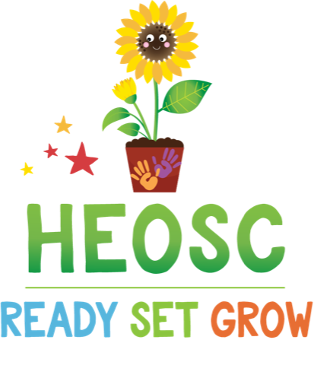

2024 – 2025 Preschool Hours

 | Monday | Tuesday | Wednesday | Thursday | Friday
Preschool – 4 hours | 9:00am – 1:00pm

2024 – 2025 Preschool Fees

Annual
Registration | $50 per Family
Emergency Fee | $10 per Child
Monthly
2 days a week (T + TH) | $273.00 ($311.00 without CCFRI)
3 days a week (M + W + F) | $320.00 ($377.00 without CCFRI)
5 days a week | $479.00 ($574.00 without CCFRI)

*Fees are subject to change

Cheques can be made out to Hillcrest Elementary Out of School Care or H.E.O.S.C. Automatic monthly debit is in use. Some initial paperwork is required. Please speak with the manager if you would like further information.

4421 Greentree Terrace
Victoria BC, V8N 3S9
Tel: 250-472-1530
Toll Free: 1-877-881-4066
Email: heoscmanager@gmail.com

